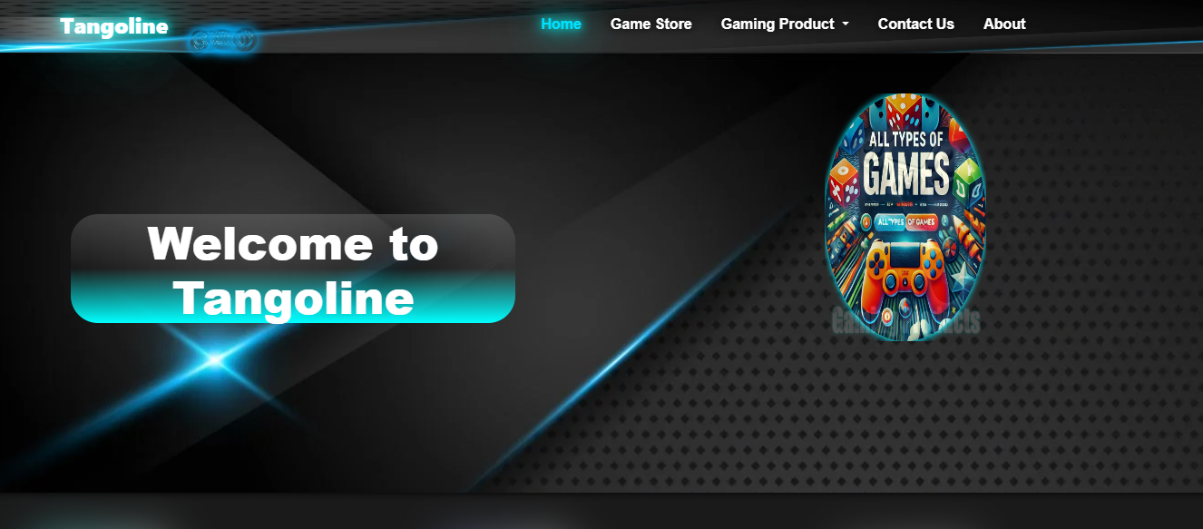

USER’S GUIDE:

Aptech North Karachi | CPISM | 18/12/2024

TABLE OF CONTENT:

* Home
* Game store
* Gaming products
* Drop down menu
* Contact us
* About

|  |  |  |
| --- | --- | --- |
|  |  |  |
| **ADVISOR/TEACHER/MENTOR** | SIR MUHAMMAD ADEEL | |
| **BATCH CODE** | 2210G2 | |
| **SERIAL NUMBER** | **ENROLLMENT NUMBER** | **STUDENT NAME** |
| 1 | **Student1592427** | **MUHAMMAD OMER NADEEM** . |
| 2 | **Student1592425** | **MUHAMMAD HAMMAD** |
| 3 | **Student1589950** | **SHAYAN ANWAR .** |
| 4 | **Student1592430** | **UMAIR ALI .** |
| 5 | **Student1590807** | **MUHAMMAD DANIYAL KHAN .** |

**HOME**

Figure:1



Figure:2

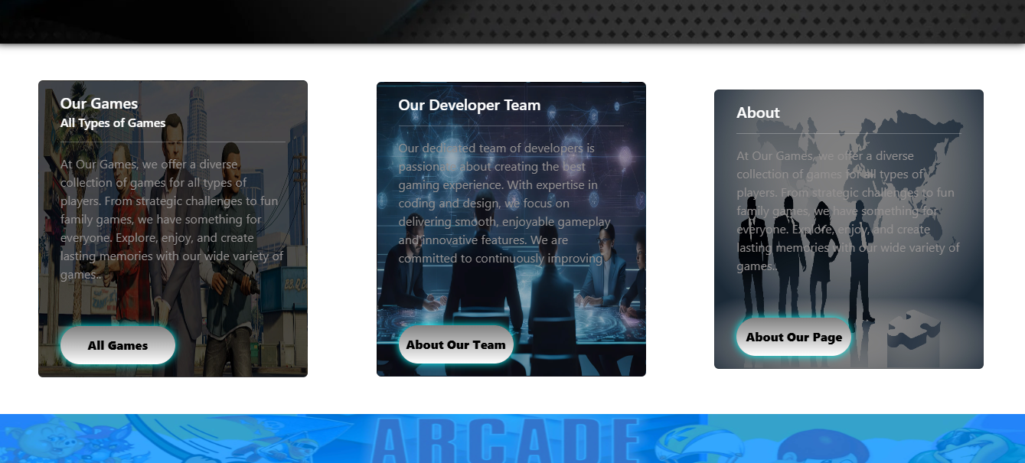

Figure:3

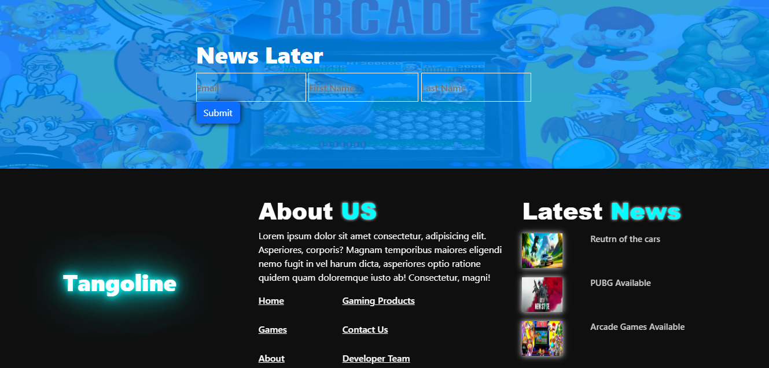

**Game store**

Figure:1

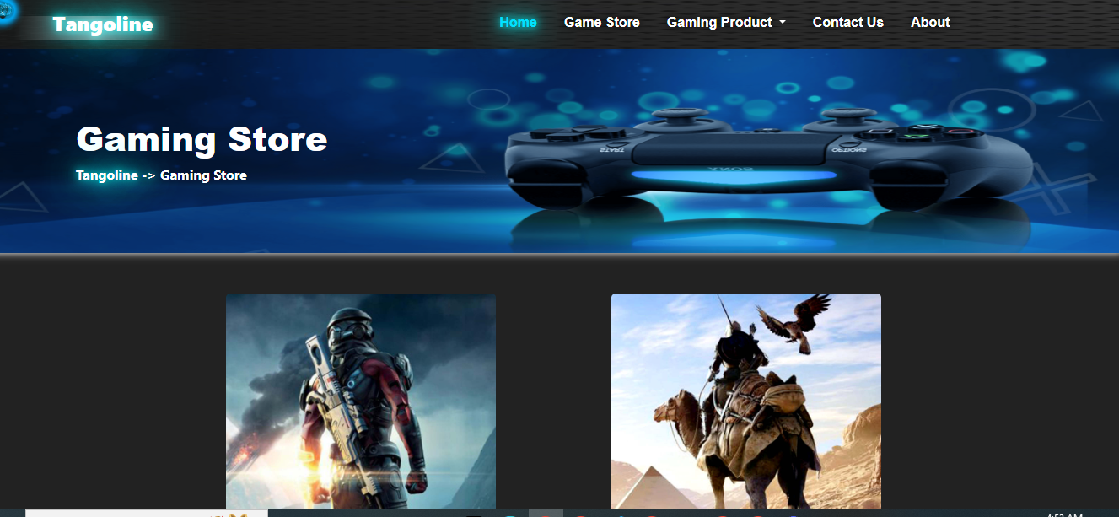

Figure:2



Figure:3

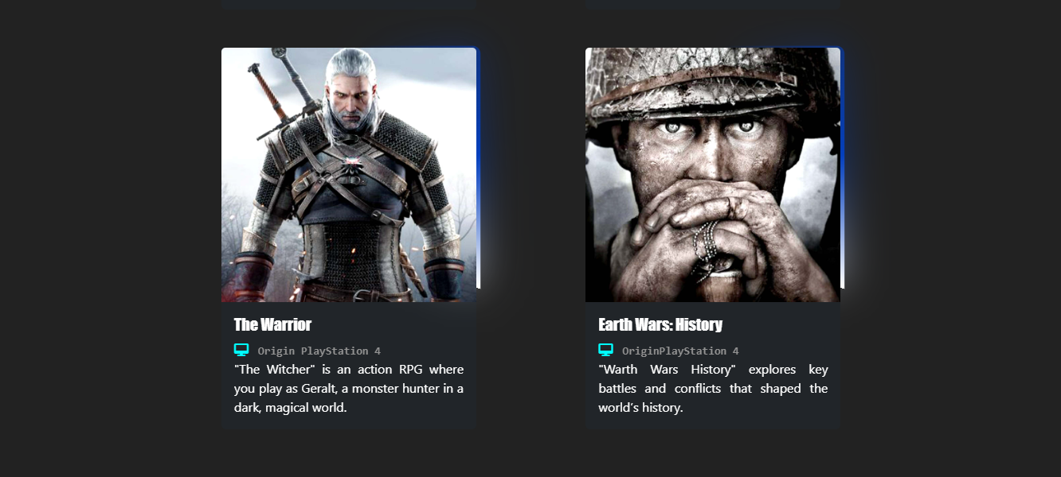

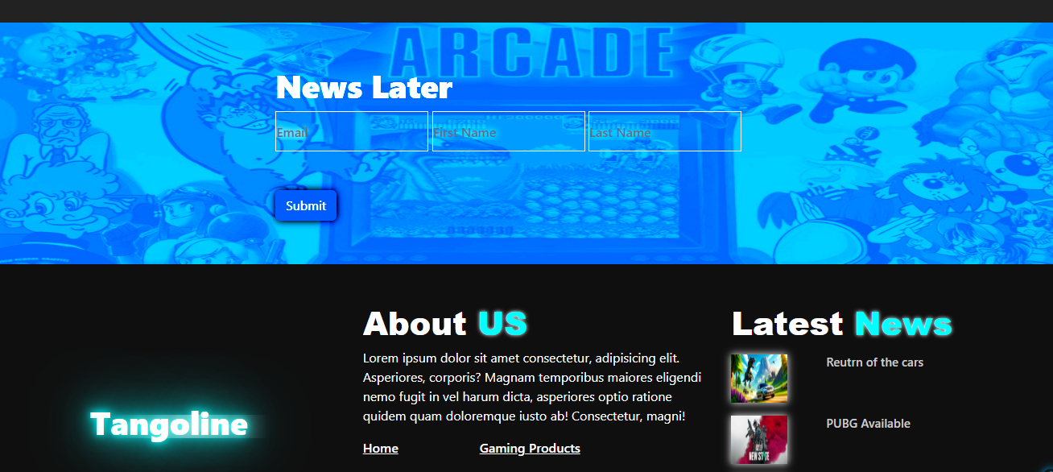

**Gaming products**

Figure:1

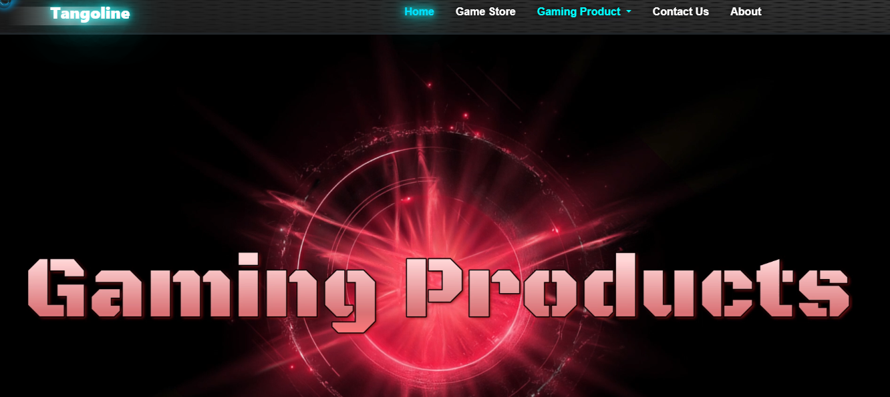

Figure:2

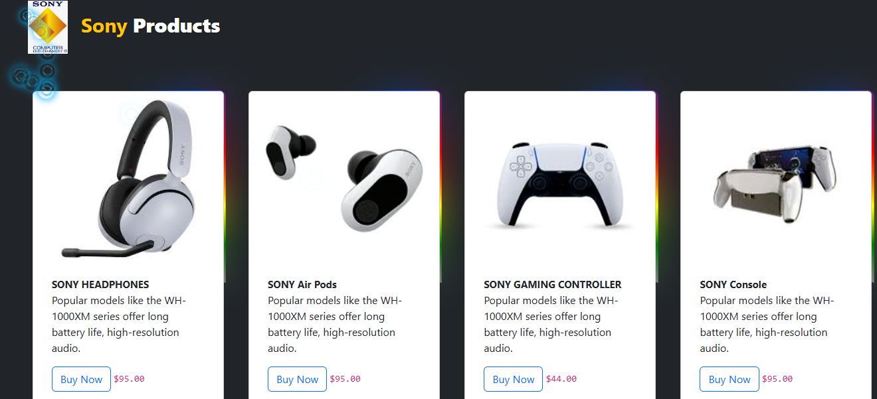

Figure:3

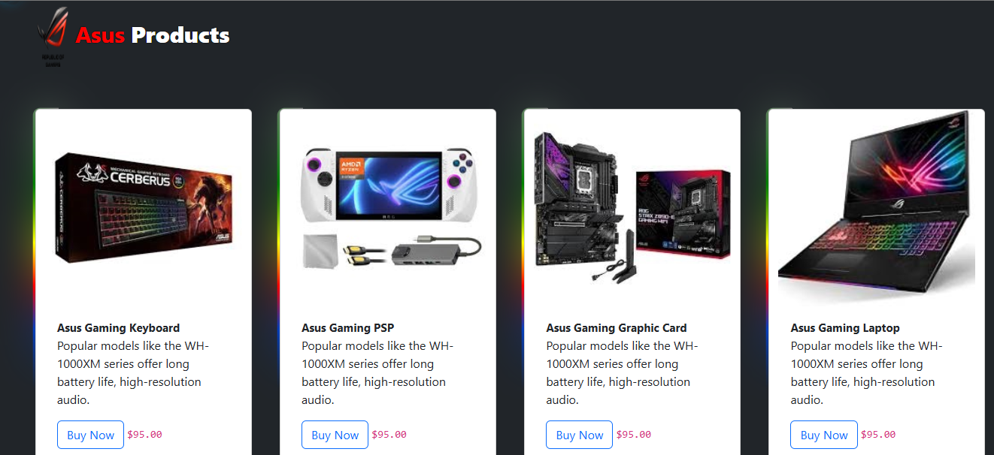

Figure:4

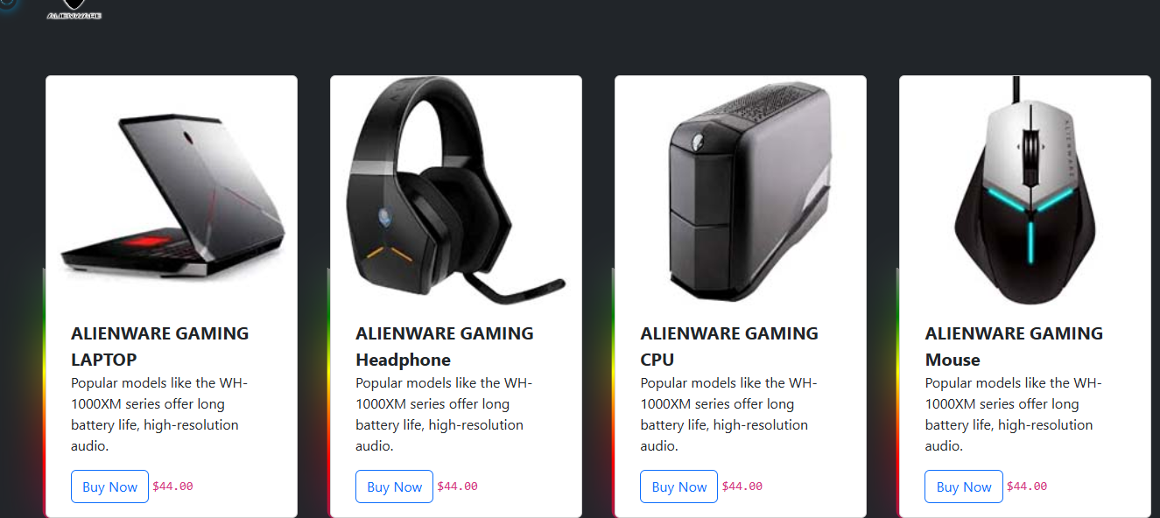

Figure:5

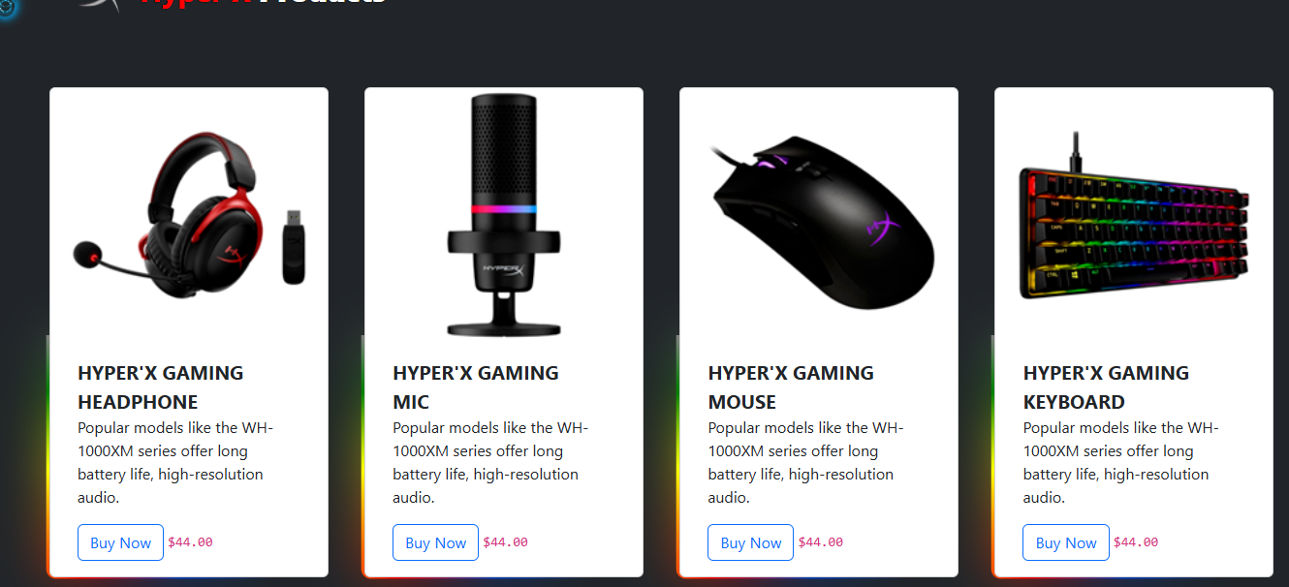

**Contact Us**

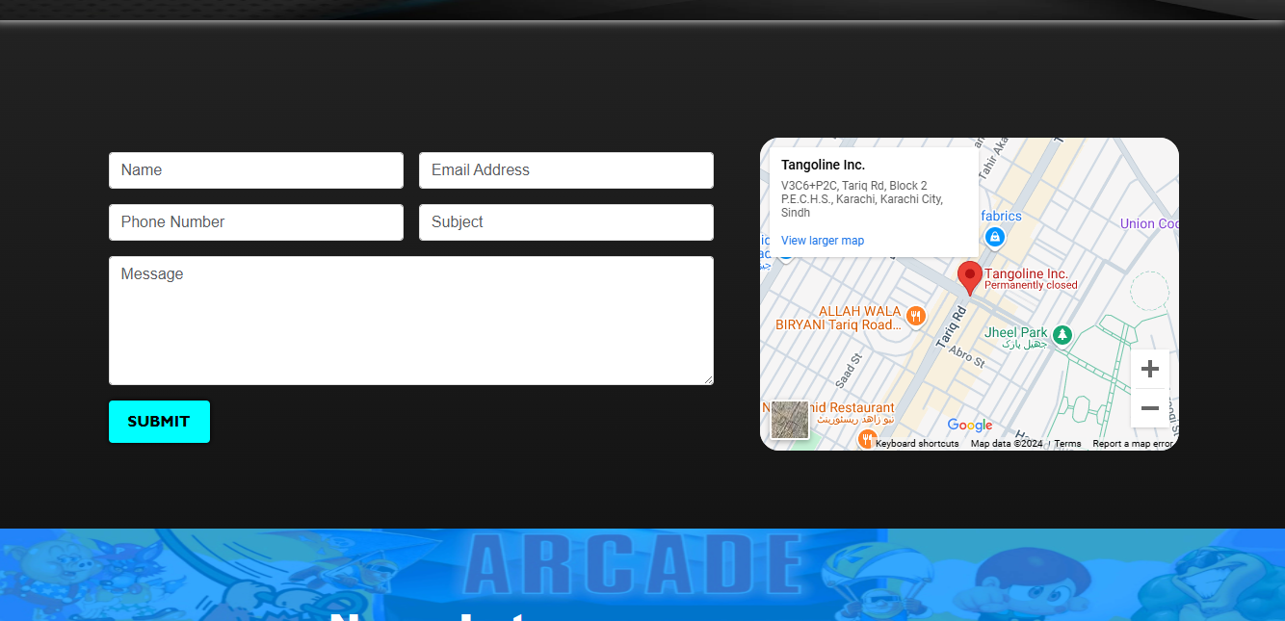Figure:1

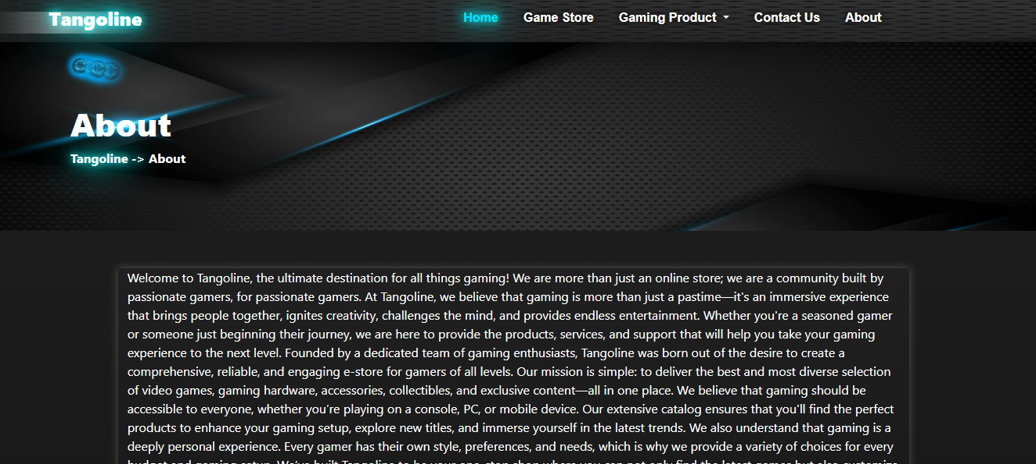**About**

Figure:2

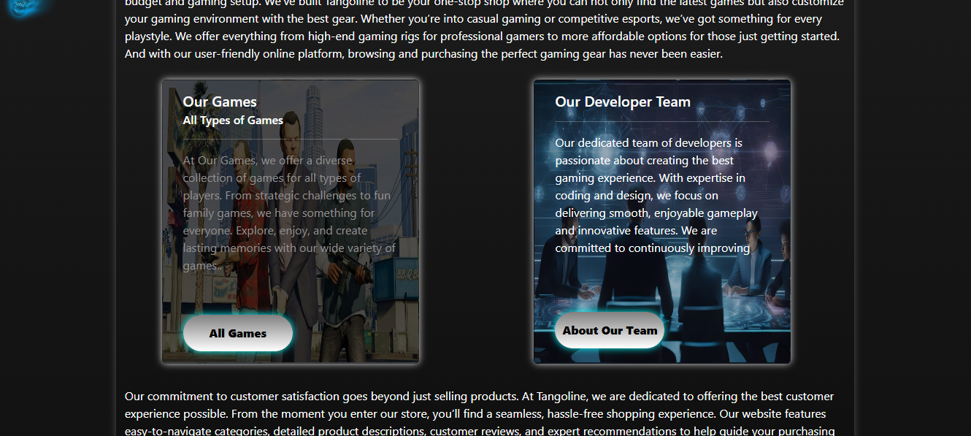

Figure:3

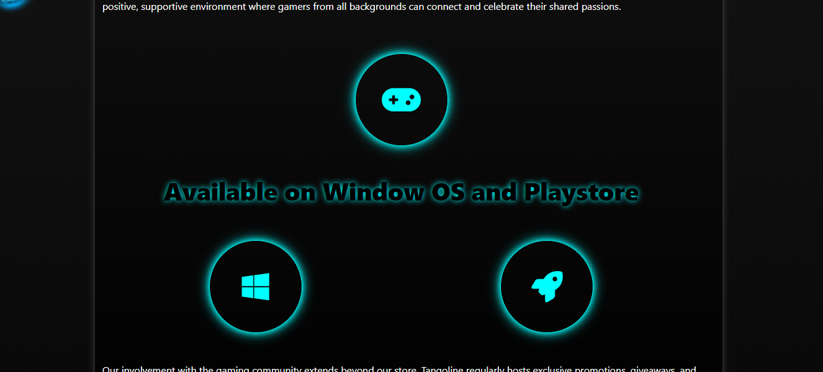

Figure:4

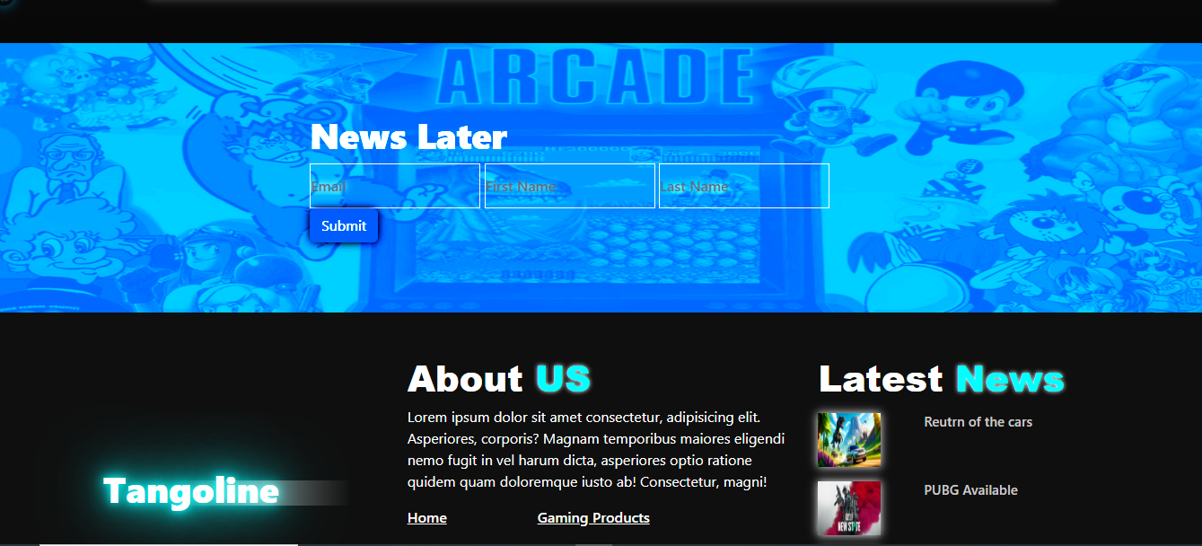

Thank you so much for reading my User Guide Manual of the Website.